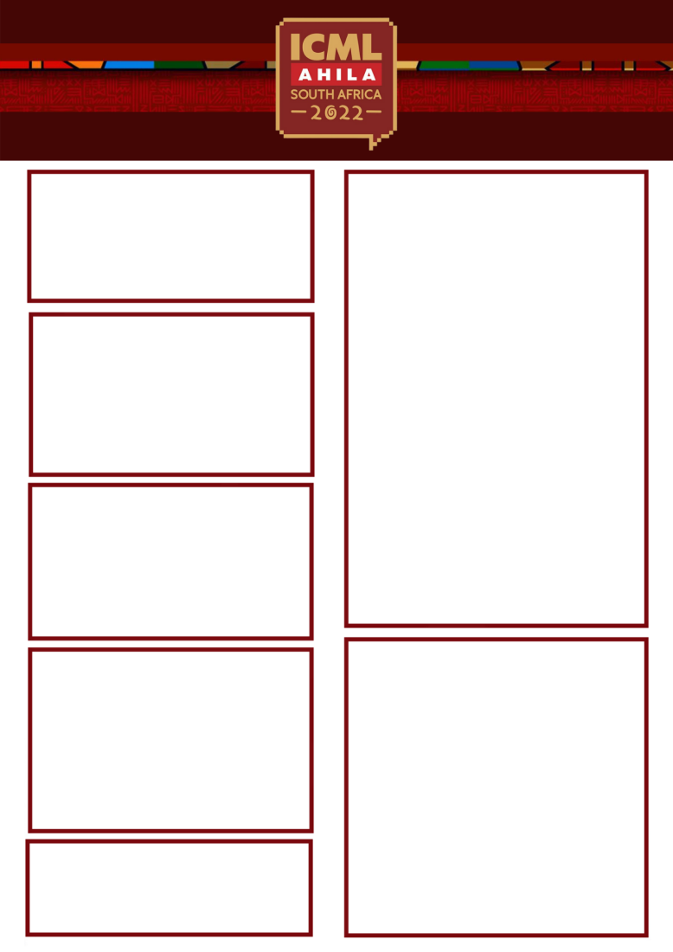

SPONSORSHIP PACKAGE
___________________________(name of the organization) would like to conﬁrm the ___________________ package

(Please specify what package you would like to conﬁrm)

PLEASE SUBMIT EXACTLY AS IT SHOULD APPEAR IN ALL PUBLISHED EVENT MATERIALS

Total Cost:

$

Name:

ADDITIONAL SPONSORSHIP OPPORTUNITIES

Organisation:

Address that will appear on the invoice:

QTY:

QTY:
City, State, Zip/Postal Code: ___________________________

Phone:

EXHIBITION
I would like to conﬁrm exhibition of:

Booth size in sq m:

Fax:

E-mail:

Cost per square meter: $

Signature:

Total Cost: $
Please complete & scan and this form, then email it along with a png high-resolution version of your company logo and a 90 word company biography to Ms. Chiedza Manuel at the information below:

E-mail: chiedza@itoca.org
Tel: + 277 12 664 1836

Payment Policy:
Full payment is due on booking. The Partner/exhibitor’s logo and company biography will not be included on any promotional materials until full payment is received.

Cancellation Policy:
Cancellation within two months prior to the conference will incur a cancellation fee of 30%. Cancellation within four months prior to the conference will incur a cancellation fee of 100%.

EXHIBITOR BADGES NAMES
Note: Two exhibitor pass is included with every booth
1.
2.
Additional Exhibitor Badges Names, cost of $10 each
1.
2.
3.

Organisation’s VAT Registration Number:

(only if based in South Africa)

.

